Week 6 day 1 and 2 (Tuesday-10th Nov)-demo notes
Sequential and concurrent execution of agents
Codeshare: https://codeshare.io/5Dd3Rl
Requirements.txt code:
agent-framework-openai
agent-framework-orchestrations
python-dotenv
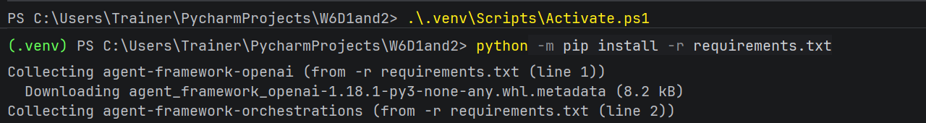
Ref:
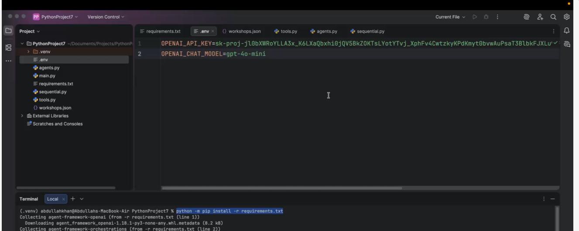

Code for workshops.json:

[
{
"id": "W101",
"title": "Python Fundamentals",
"duration_days": 2,
"fee": 3000
},
{
"id": "W102",
"title": "Advanced Python",
"duration_days": 3,
"fee": 4500
},
{
"id": "W103",
"title": "Azure Fundamentals",
"duration_days": 2,
"fee": 5000
},
{
"id": "W104",
"title": "Power BI Essentials",
"duration_days": 2,
"fee": 4000
}
]
Tools.py ref:
2 tools-same as before
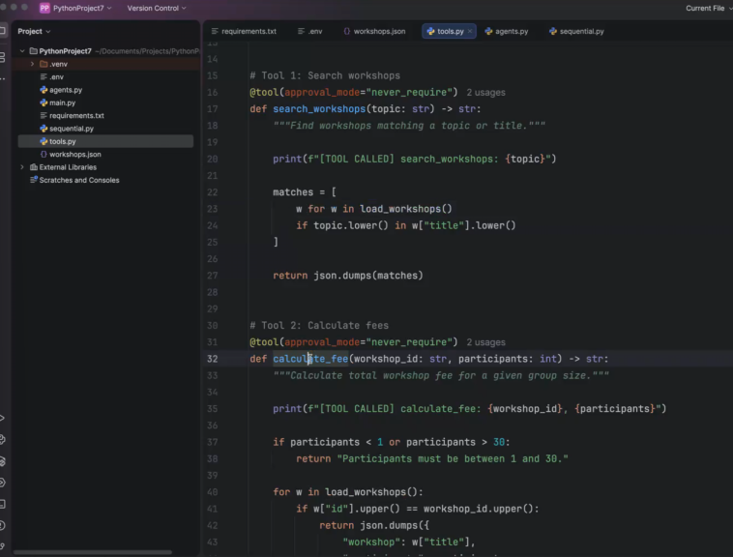
Code for tools.py:
import json
from pathlib import Path

from agent_framework import tool

DATA_FILE = Path(__file__).parent / "workshops.json"

def load_workshops():
return json.loads(DATA_FILE.read_text(encoding="utf-8"))

# Tool 1: Search workshops
@tool(approval_mode="never_require")
def search_workshops(topic: str) -> str:
"""Find workshops matching a topic or title."""

print(f"[TOOL CALLED] search_workshops: {topic}")

matches = [
w for w in load_workshops()
if topic.lower() in w["title"].lower()
]

return json.dumps(matches)

# Tool 2: Calculate fees
@tool(approval_mode="never_require")
def calculate_fee(workshop_id: str, participants: int) -> str:
"""Calculate total workshop fee for a given group size."""

print(f"[TOOL CALLED] calculate_fee: {workshop_id}, {participants}")

if participants < 1 or participants > 30:
return "Participants must be between 1 and 30."

for w in load_workshops():
if w["id"].upper() == workshop_id.upper():
return json.dumps({
"workshop": w["title"],
"participants": participants,
"fee_per_person": w["fee"],
"total_fee": w["fee"] * participants,
"currency": "INR"
})

return "Workshop not found."
Agents.py ref: 3 agents
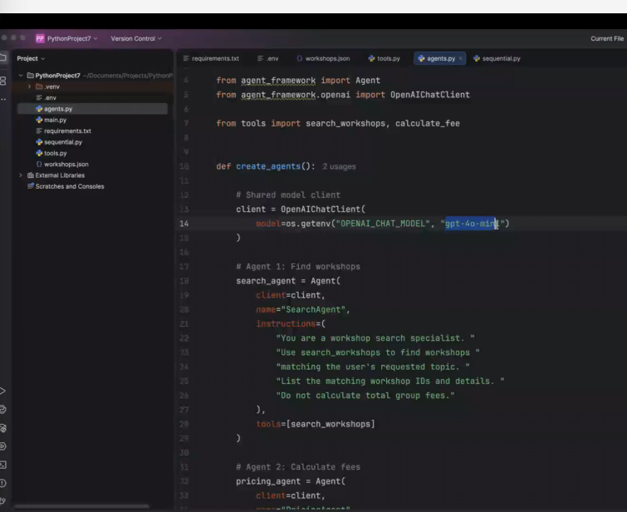gpt4omini is client
Focus concentrated using “intstructions inside search agent”
Using the same model, but making it focused
Code for agents.py;

import os

from agent_framework import Agent
from agent_framework.openai import OpenAIChatClient

from tools import search_workshops, calculate_fee

def create_agents():

# Shared model client
client = OpenAIChatClient(
model=os.getenv("OPENAI_CHAT_MODEL", "gpt-4o-mini")
)

# Agent 1: Find workshops
search_agent = Agent(
client=client,
name="SearchAgent",
instructions=(
"You are a workshop search specialist. "
"Use search_workshops to find workshops "
"matching the user's requested topic. "
"List the matching workshop IDs and details. "
"Do not calculate total group fees."
),
tools=[search_workshops]
)

# Agent 2: Calculate fees
pricing_agent = Agent(
client=client,
name="PricingAgent",
instructions=(
"You are a workshop pricing specialist. "
"Read the previous search results and user request. "
"Use calculate_fee for each matching workshop "
"using the requested number of participants. "
"Report the verified totals. "
"Never invent prices."
),
tools=[calculate_fee]
)

# Agent 3: Recommend
recommendation_agent = Agent(
client=client,
name="RecommendationAgent",
instructions=(
"You are a workshop recommendation specialist. "
"Read the search and pricing results. "
"Recommend the best matching workshop "
"within the user's budget. "
"Explain your choice briefly. "
"Use only verified workshop data and totals."
)
)

return search_agent, pricing_agent, recommendation_agent
POINT- can we use different models for different agents ? yes- but they should be agentic models(mostly free models are not agentic)-see documentation
Sequential.py ref:
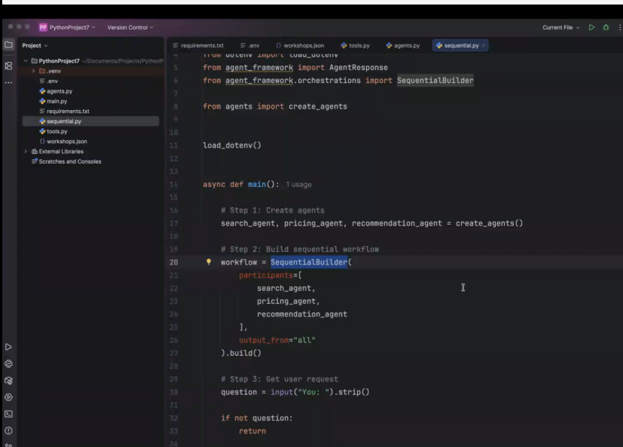
Use sequential builder if you wanna call agents one after another
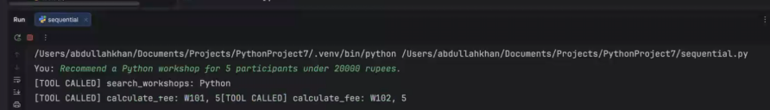
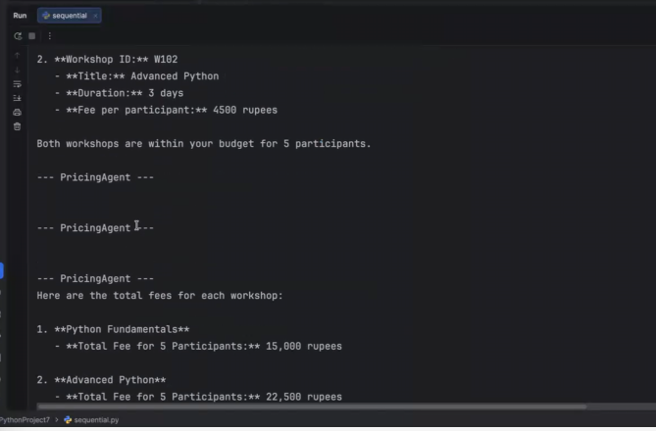
Reasoning given by recommender agent.
Code for sequential.py :

import asyncio

from dotenv import load_dotenv
from agent_framework import AgentResponse
from agent_framework.orchestrations import SequentialBuilder

from agents import create_agents

load_dotenv()

async def main():

# Step 1: Create agents
search_agent, pricing_agent, recommendation_agent = create_agents()

# Step 2: Build sequential workflow
workflow = SequentialBuilder(
participants=[
search_agent,
pricing_agent,
recommendation_agent
],
output_from="all"
).build()

# Step 3: Get user request
question = input("You: ").strip()

if not question:
return

# Step 4: Execute workflow
result = await workflow.run(question)

# Step 5: Display each agent's response
for output in result.get_outputs():

if isinstance(output, AgentResponse):
for message in output.messages:
print(f"\n--- {message.author_name or 'Agent'} ---")
print(message.text)

if __name__ == "__main__":
asyncio.run(main())
Output:
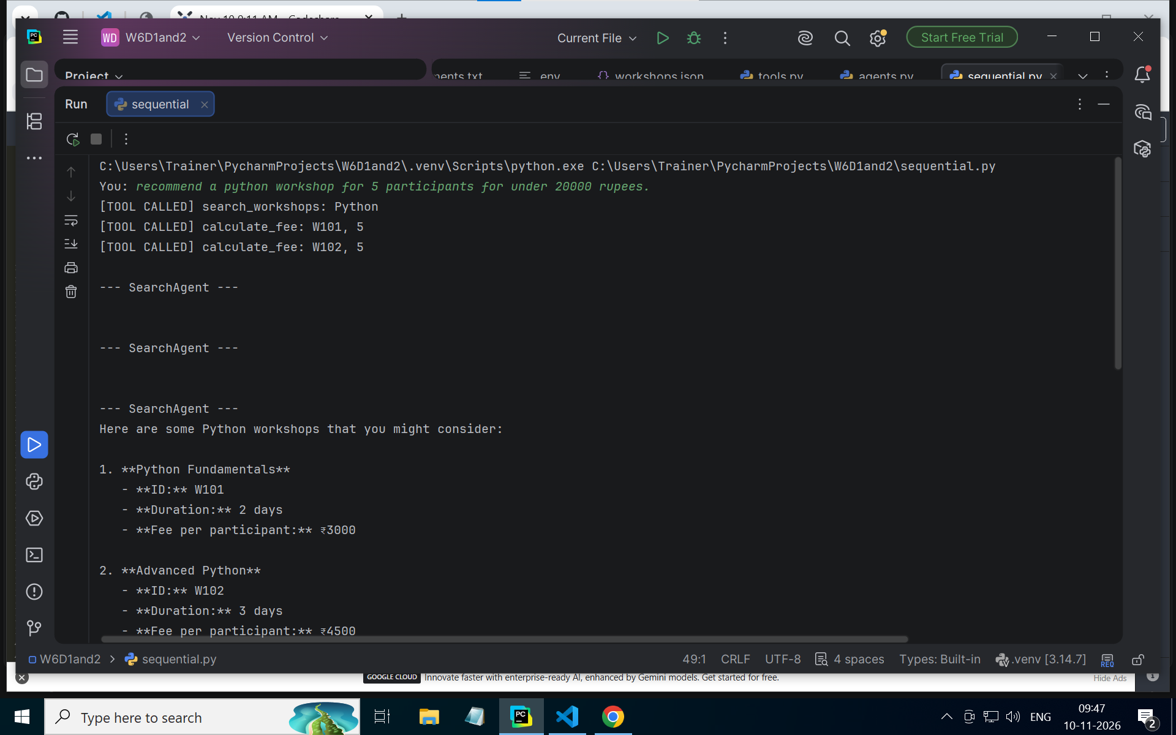
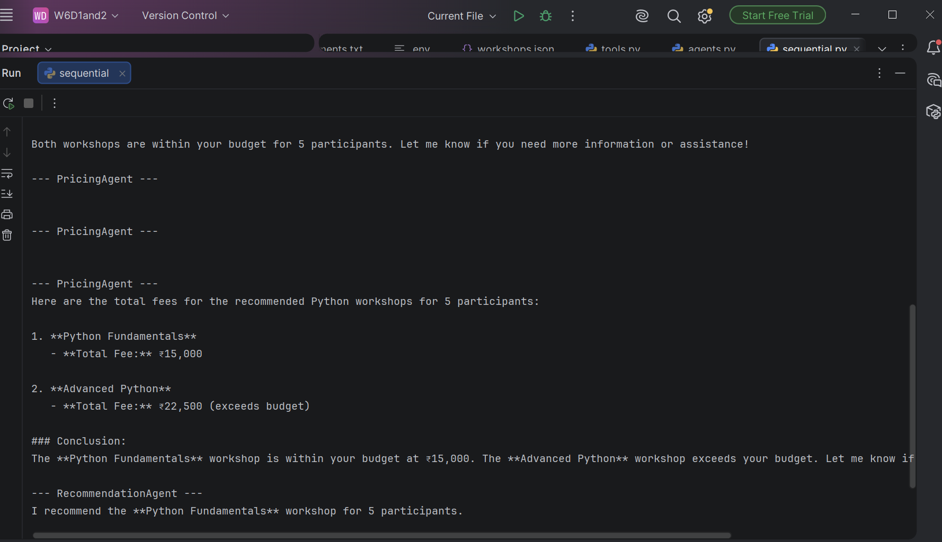
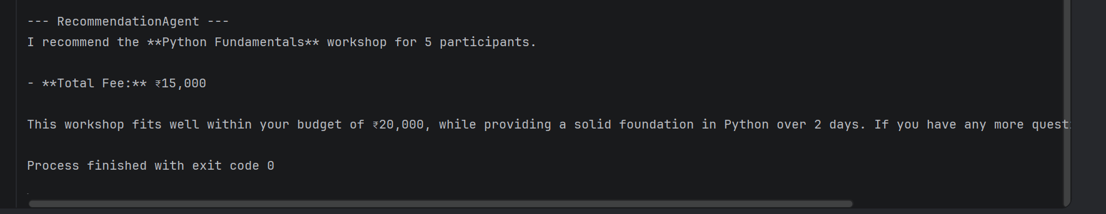
Assignment-sequential builder (see file in git repo)

